Name _____________________
Cylinder and Cone
What is the volume of the volume of a cylinder?
$V=$_____________________
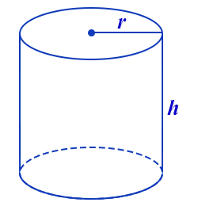

What is the volume of a cone?

$V=$_____________________
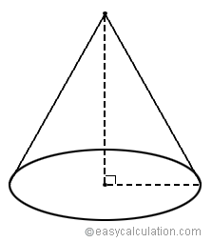

Practice Problems
- Which expression represents the volume, in cubic centimeters, of the cylinder represented in the diagram below?

- A cylindrical container has a diameter of 12 inches and a height of 15 inches. What is the volume?
- The volume of a cylindrical can is 32π cubic inches. If the height of the can is 2 inches, what is its radius, in inches?
- A soup can is in the shape of a cylinder. The can has a volume of 342 cm3 and a diameter of 6 cm. Express the height of the can in terms of π.

- In the diagram below, a right circular cone has a diameter of 8 inches and a height of 12 inches. What is the volume of the cone to the nearest cubic inch?
- A water cup in the shape of a cone has a height of 4 inches and a maximum diameter of 3 inches. What is the volume of the water in the cup, to the nearest tenth of a cubic inch?

- An ice cream waffle cone can be modeled by a right circular cone with a base diameter of 6.6 centimeters and a volume of 54.45π cubic centimeters. What is the number of centimeters in the height of the waffle cone?

- A cone has a volume of 24π cubic inches and a radius of 3 inches. Determine and state the height, in inches, of the cone.

